Title: GUIDELINE, ASCENX DRAWING TEMPLATE, ORCAD
Summary: OrCAD Drawing Template for B size Guideline

Name |  | Initial / Date | Distribution Restriction
Prepared by | Hanh Nguyen | 22/06/2010 | This document has distribution restrictions
Approved by | Hoan Le |  | This document has distribution restrictions

Revision | Change ECO # | Originator | Approver | Date
AA | 00005 | Hanh Nguyen | Hoan Le
- OVERVIEW
This procedure use to instruct how to use a template in OrCAD software for making all Ascenx’s drawings.

- SCOPE
- Provide step by step instructions to use OrCAD drawing template B size for all drawings of Ascenx in OrCAD software included: page size, title block…
- All design engineers must follow this procedure to make all drawings of Ascenx.

- DEFINITIONS
APDM: Ascenx Product Data Management
OrCAD: 2D/3D software from Cadence Design Systems Inc.
*.olb file: Titleblock Library file (from OrCAD)

- ROLES AND RESPONSIBILITIES
- All changes to improve for all templates will be done by originator and approved by leader or manager.
- All users must use these templates for all drawings of Ascenx and feedback to person in charge when user need update information to template.

- REFERENCE DOCUMENTS AND WEB ADDRESSES
N/A

- REQUIRED TOOLS AND EQUIPMENTS
Install OrCAD software to computer before using these templates for creating Ascenx drawing.

- PREPARATIONS AND WARNINGS
N/A

- PROCEDURE STEPS
Step 1: Get Titleblock template by using Titleblock Library from APDM
Go to link and login:
http://app.ascenx.com/oem/administrator
Note:
Please contact Document Control to have new account to access to APDM. See Figure 1.
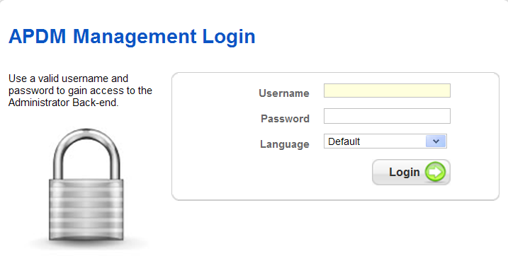

Figure 1
The Titleblock Library file is stored in APDM, and controlled by Part Number as below:
TEMPLATE, ORCAD DRAWING, ASCENX with P/N: 525-000002-03-AA
Note:
After getting the Titleblock library file from, please put it into the library of project.

Step 2: Make a new drawing by using the OrCAD software.
2.1 OrCAD software:
Choose File -> New -> Project. See Figure 2

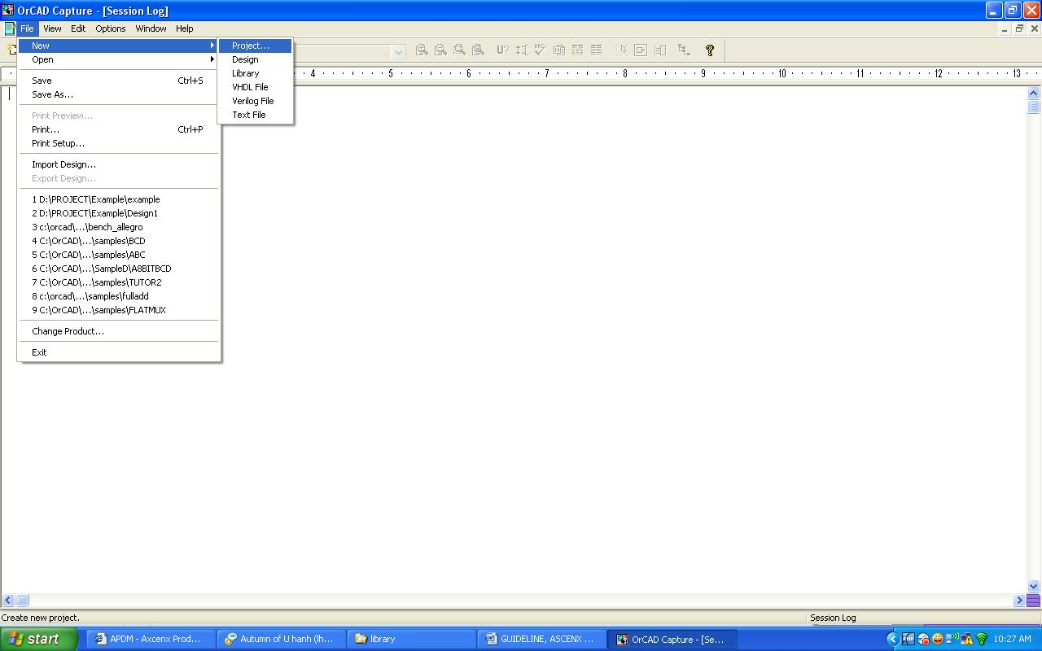
Figure 2
Get the below window. See Figure 3
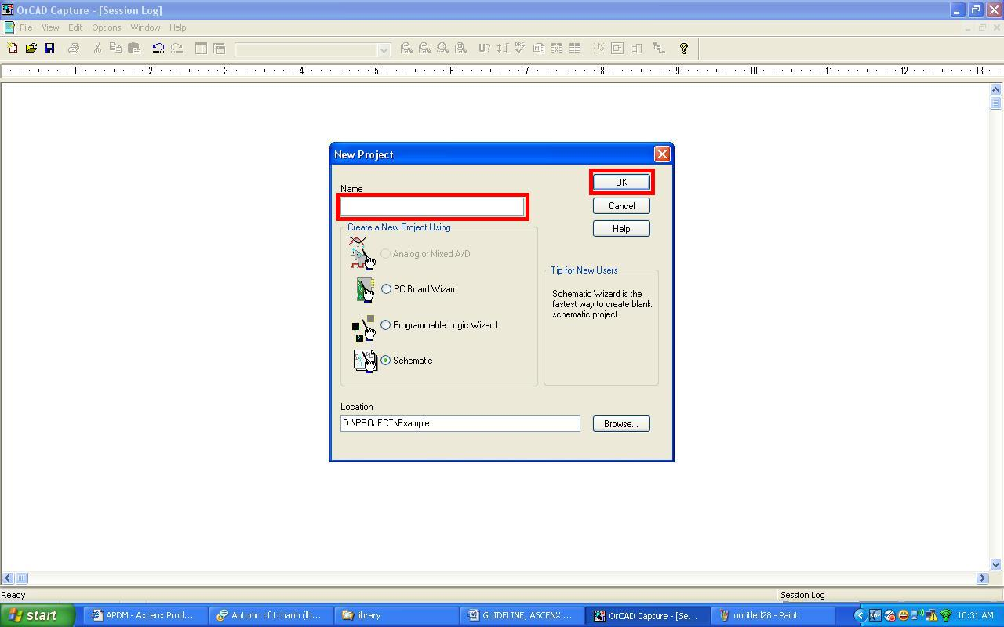

Figure 3

Enter the name of project and click OK. See Figure 4

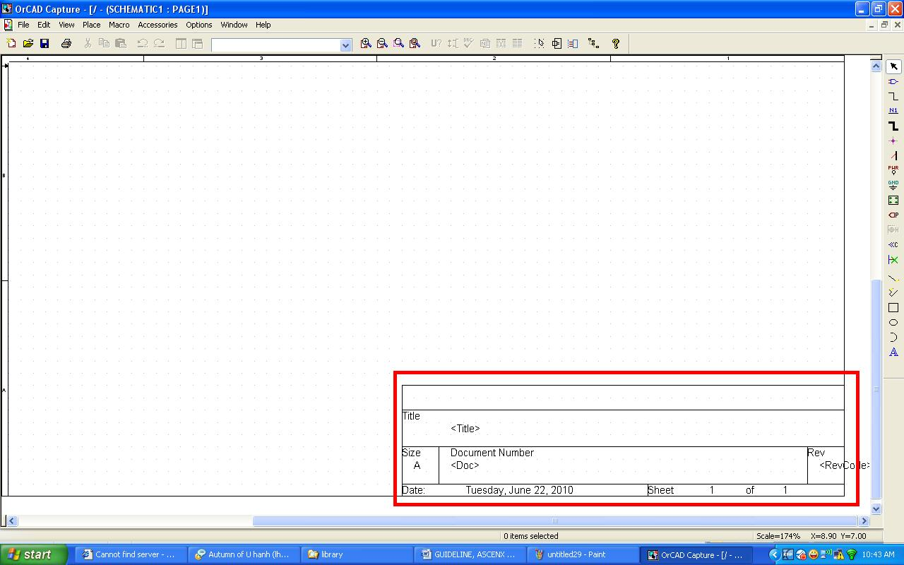

Figure 4

Delete the existing titleblock in the drawing. See Figure 5

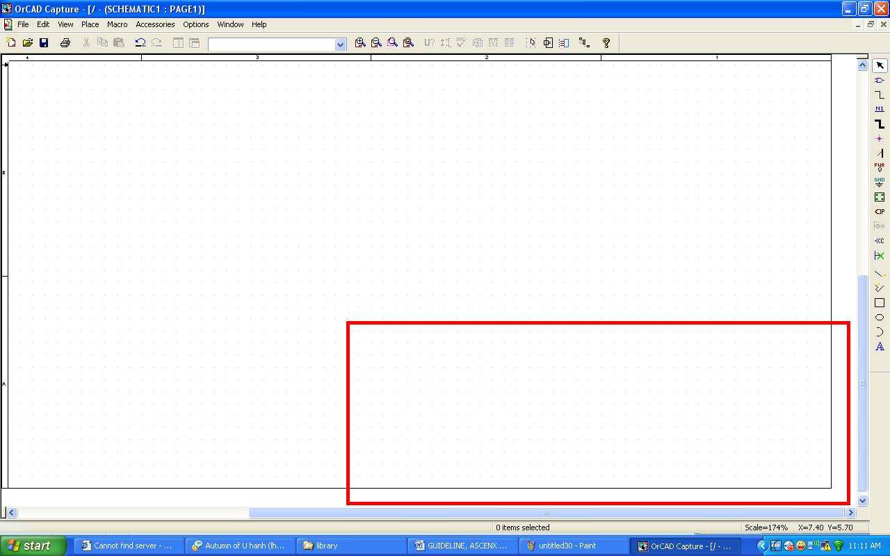

Figure 5

Select the page size. See Figure 6

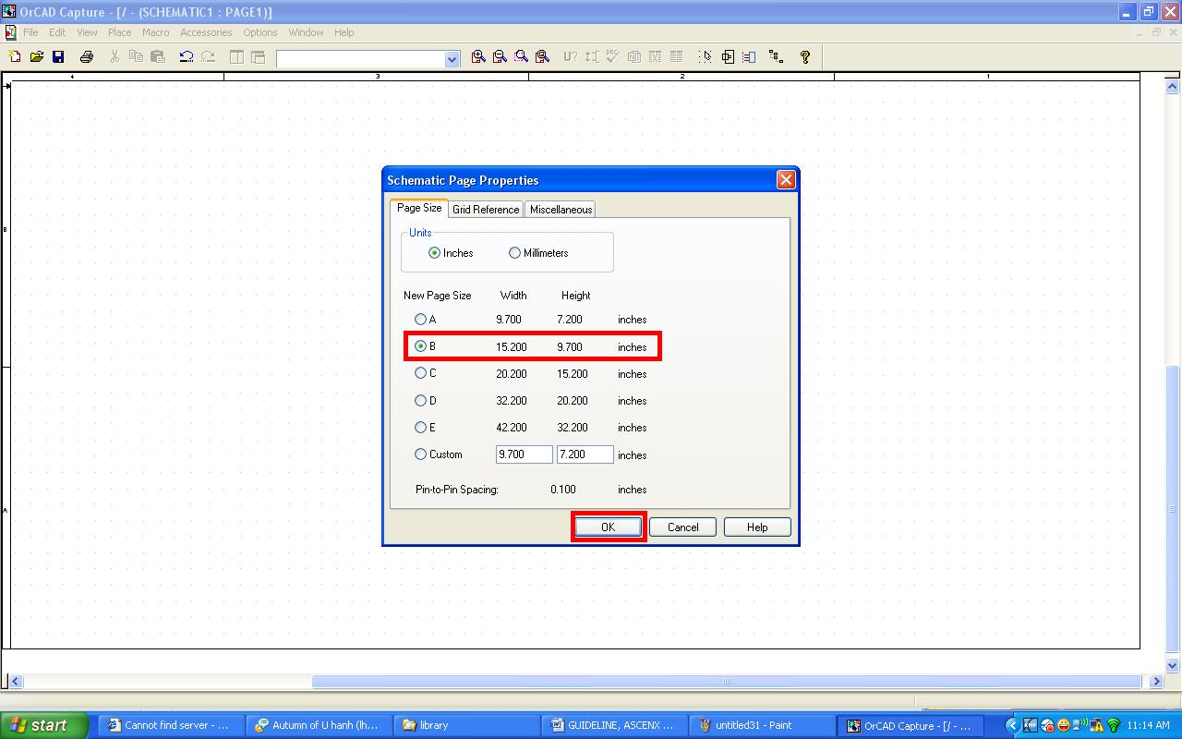

Figure 6
Choose the size which you need and click OK. (Ex: B size)

Choose Place -> Titleblock … See Figure 7

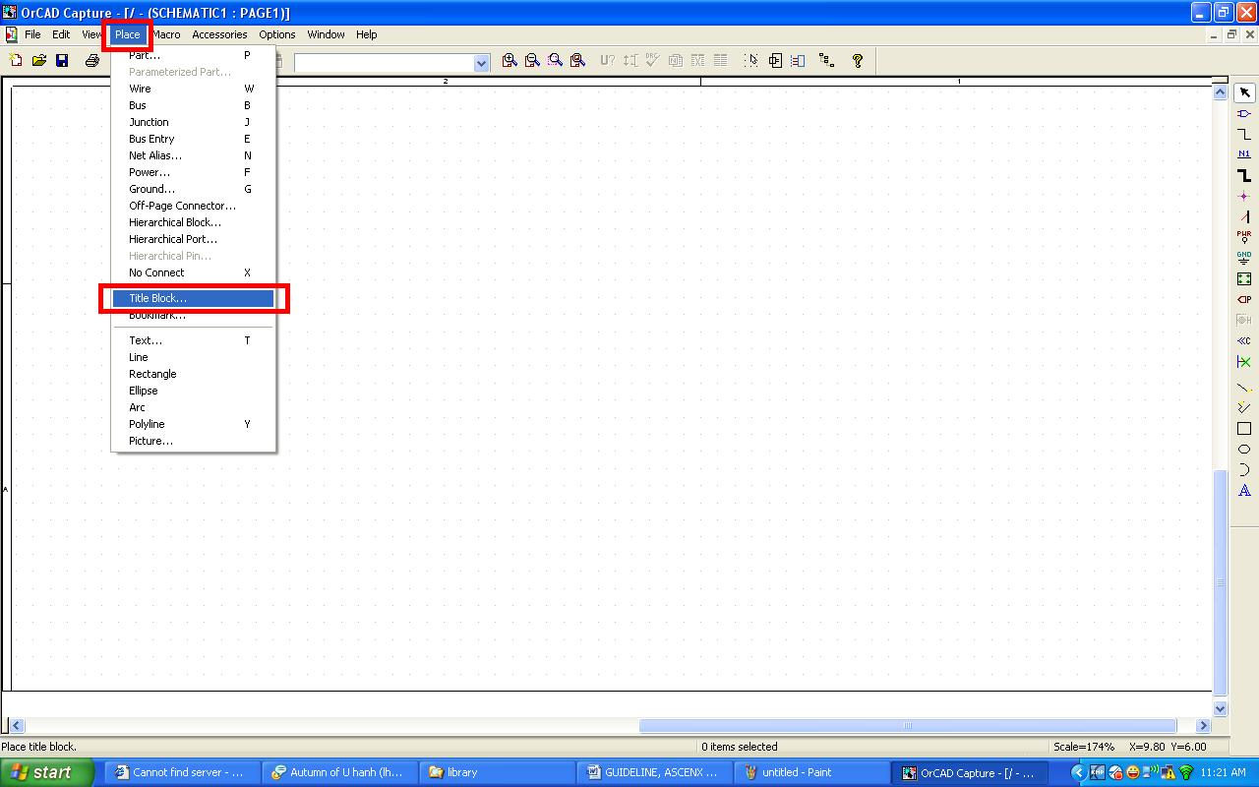

Figure 7

Choose the Titleblock which you need. See Figure 8

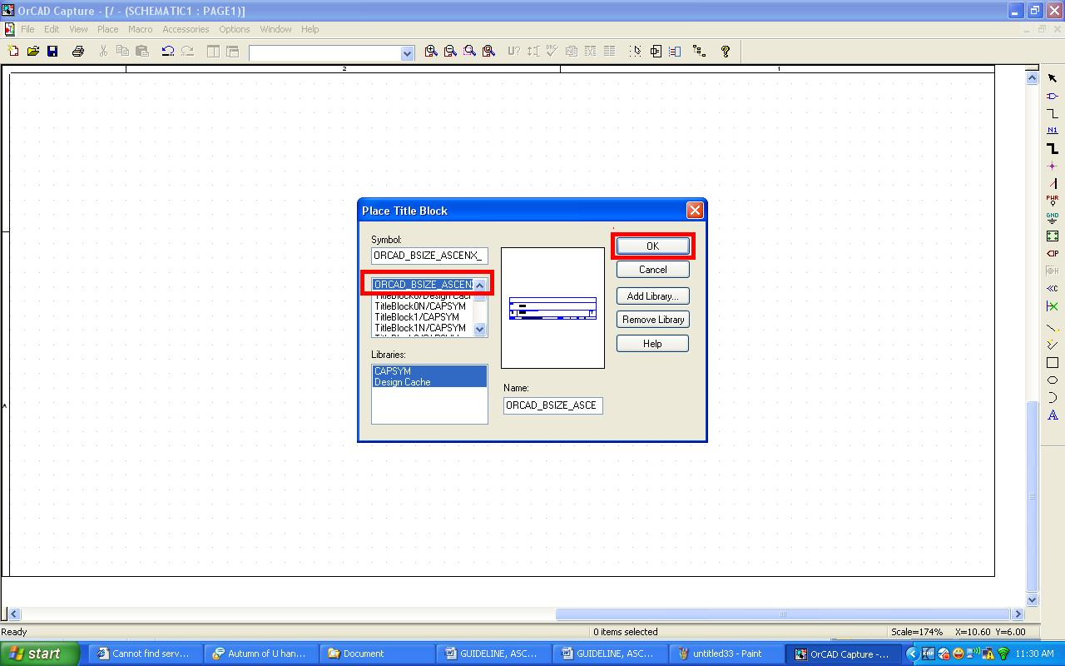

Figure 8

Ex: Get the Template, OrCAD drawing, B-size, Ascenx. (*.OLB or *.MAX ) See Figure 9

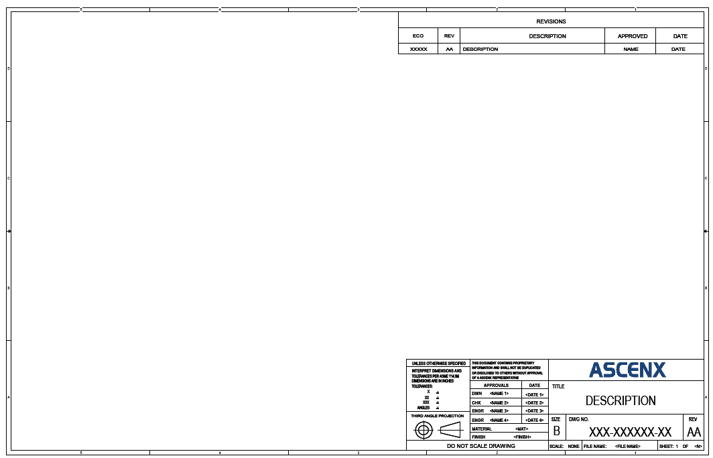

Figure 9
Enter all information of Titleblock.
- APPENDIX
N/A

